Directions for Registering as a Coach
Step 1: Go to www.whatcomsoccer.com, select “Register Now,” scroll down and select “Register” under Ferndale Red Lions.
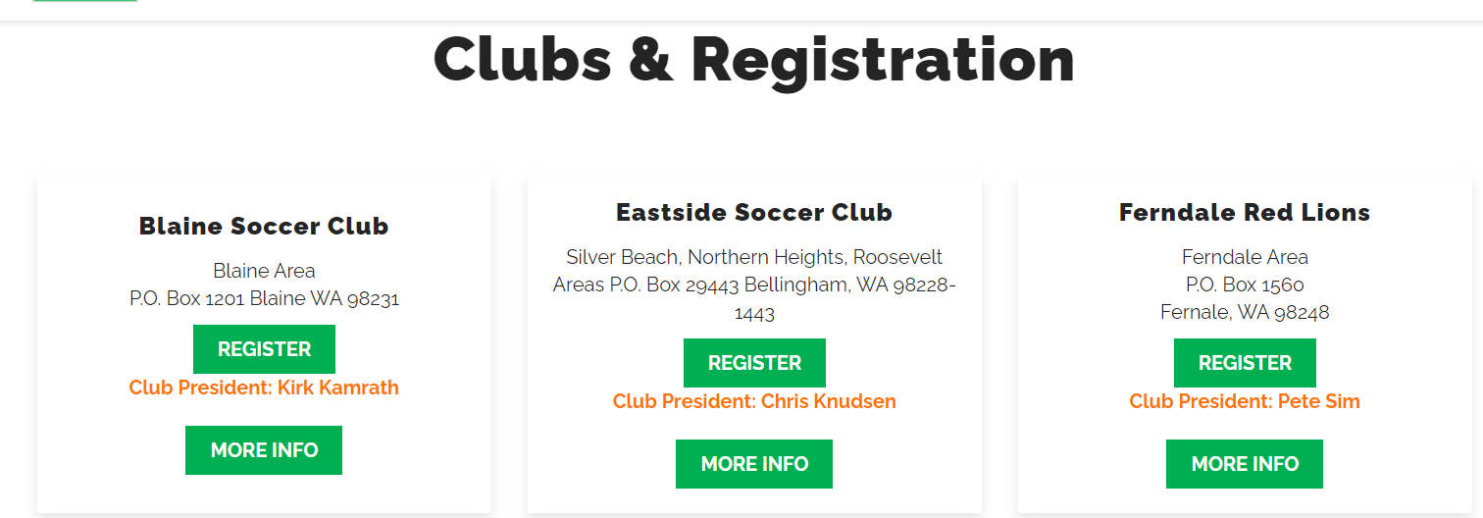
Step 2: Log in to Sports Connect
Step 3: Update any information needed
Step 4: Choose “My Account”
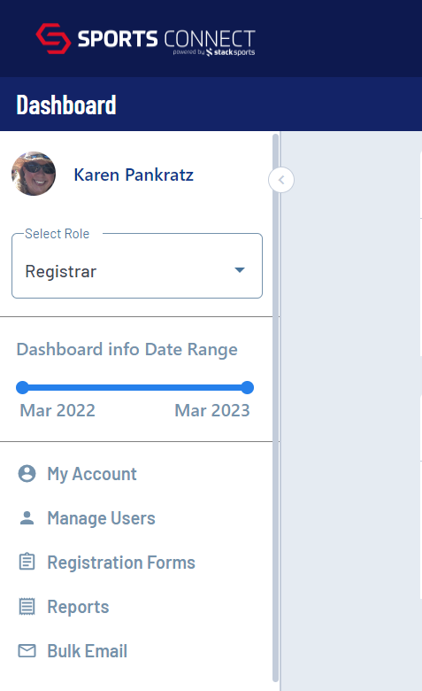
Step 5: Click on “Volunteer”
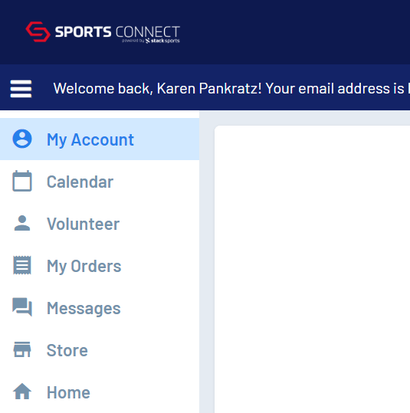
Step 6: Click on “Find Volunteer Roles”
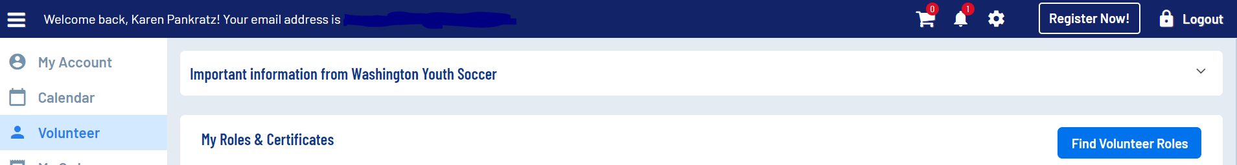
Step 7: Click on “View Divisions”
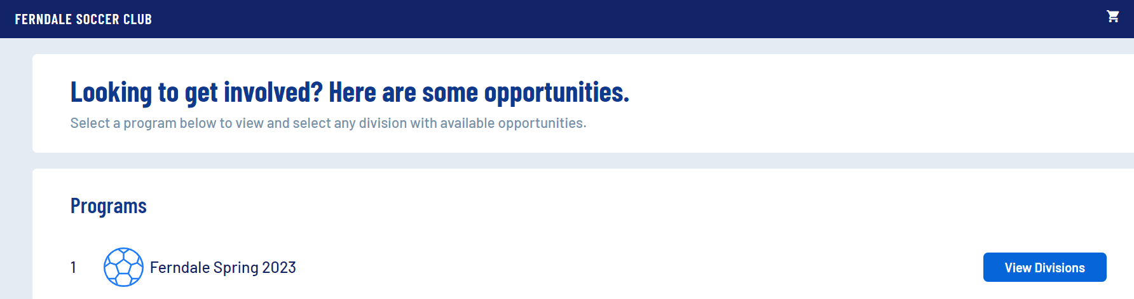
Step 8: Choose the division you would like to coach and click “View Selected Opportunities”
Step 9: Press the opportunity that you would like to volunteer for
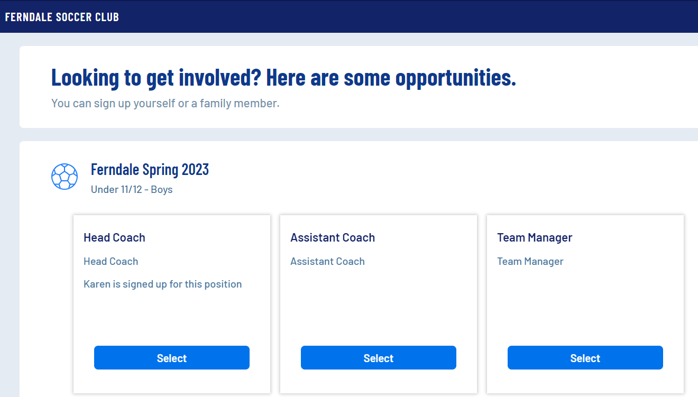
Step 10: Choose the person you would like to sign up for the role and then press “Continue”
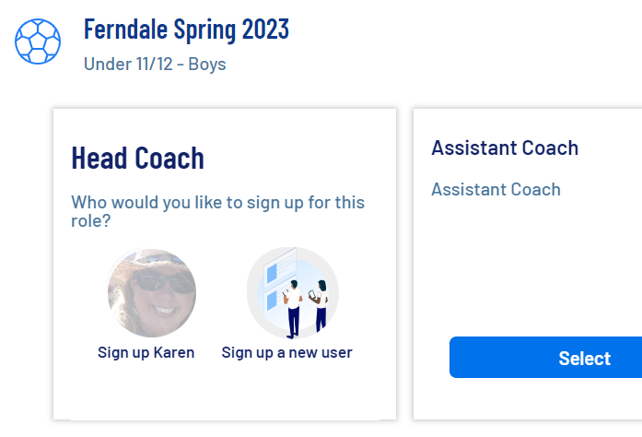
Step 11: Complete the registration form
Step 12: You will be taken to a screen to upload or complete your certifications. Select the certifications you need to take and then press “Renew & Update”
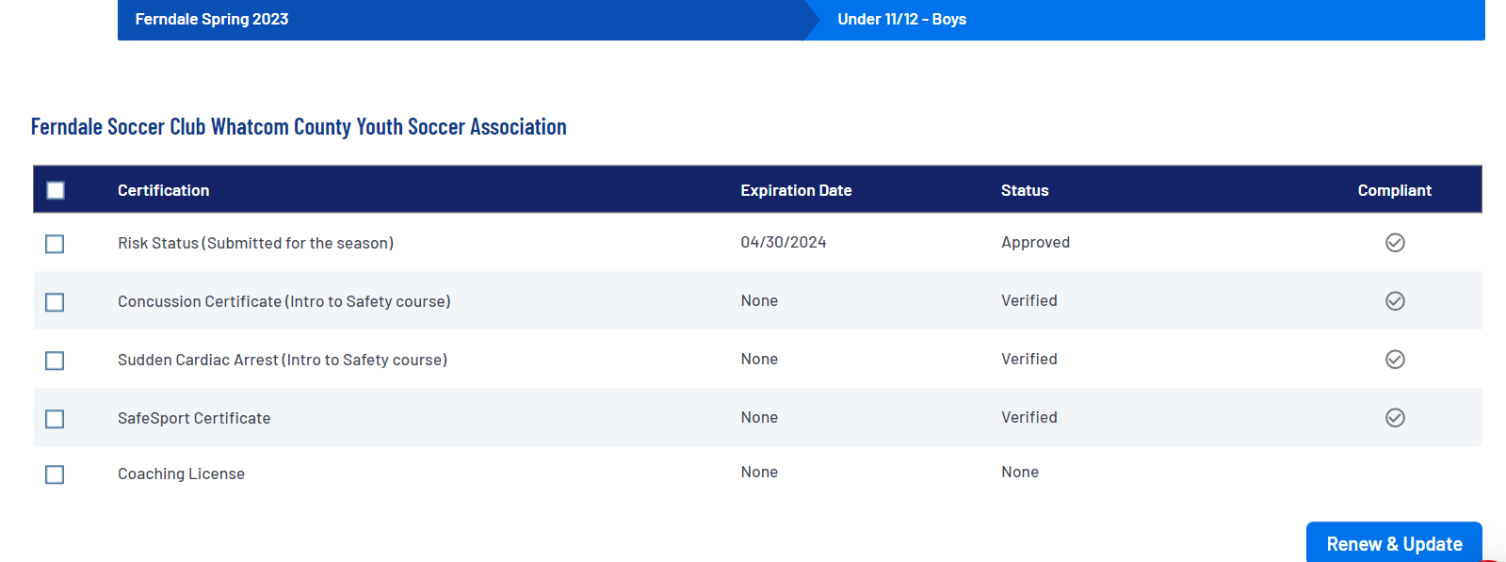
Step 13: The following screen will appear. All certifications are found at the same webpage and can be accessed by clicking the link.
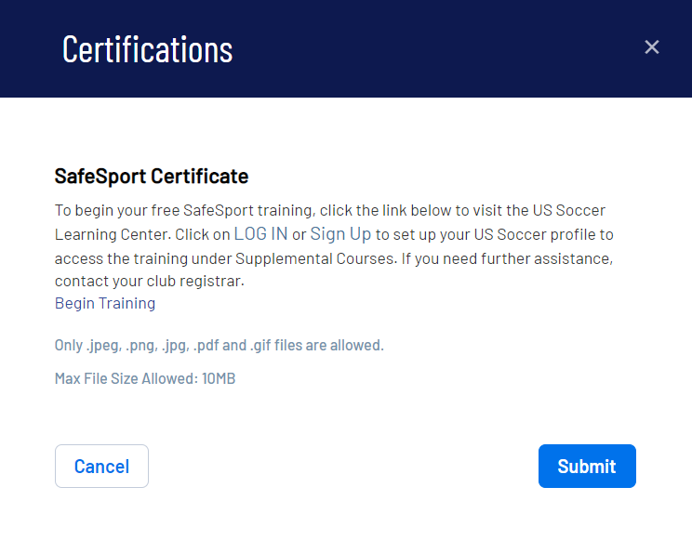
Step 14: You will be brought to U.S. Soccer Learning Center (ussoccer.com) and will need to Log In (if you have an account or Sign Up, if you do not.
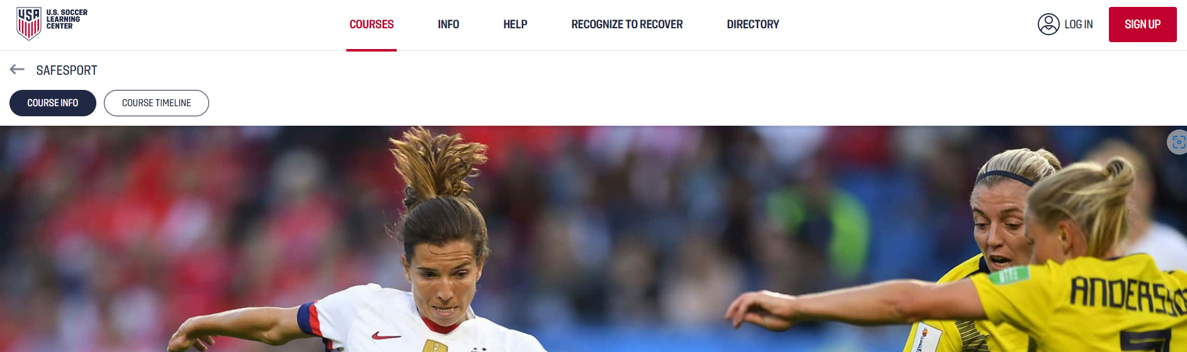

Step 15: Once you are logged in, exit the tutorial it will automatically begin. Click on “Supplemental Courses”
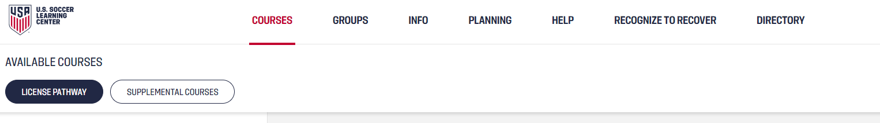
Step 16: Click on “SafeSport” or “Intro to Safety” – whichever one you are working on
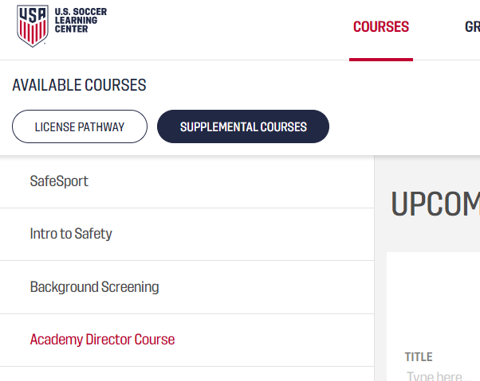
Note: The “Intro to Safety” course includes both the Concussion Certification and the Sudden Cardiac Arrest certification
Step 17: Complete the course, renew the course, or resume, if it’s not completed
